# Phase 1 Practice Project – Assisted Practice

**3. Write a program in java implementing the Exponential search algorithm.**

**package** algorithms;

**public** **class** ExponentialSearch {

**public** **static** **int** binarySearch(**int** arr[], **int** left, **int** right, **int** target) {

**if** (right >= left) {

**int** mid = left + (right - left) / 2;

**if** (arr[mid] == target) {

**return** mid; // Element found, return its index

}

**if** (arr[mid] > target) {

**return** *binarySearch*(arr, left, mid - 1, target);

}

**return** *binarySearch*(arr, mid + 1, right, target);

}

**return** -1; // Element not found in the array

}

**public** **static** **int** exponentialSearch(**int** arr[], **int** target) {

**if** (arr[0] == target) {

**return** 0; // Element found at the first position

}

**int** i = 1;

**while** (i < arr.length && arr[i] <= target) {

i *= 2;

}

**return** *binarySearch*(arr, i / 2, Math.*min*(i, arr.length - 1), target);

}

**public** **static** **void** main(String[] args) {

**int**[] arr = {5, 8, 12, 17, 23, 30, 40};

**int** target = 17;

**int** index = *exponentialSearch*(arr, target);

**if** (index != -1) {

System.***out***.println("Element " + target + " found at index " + index);

} **else** {

System.***out***.println("Element " + target + " not found in the array.");

}

}

}

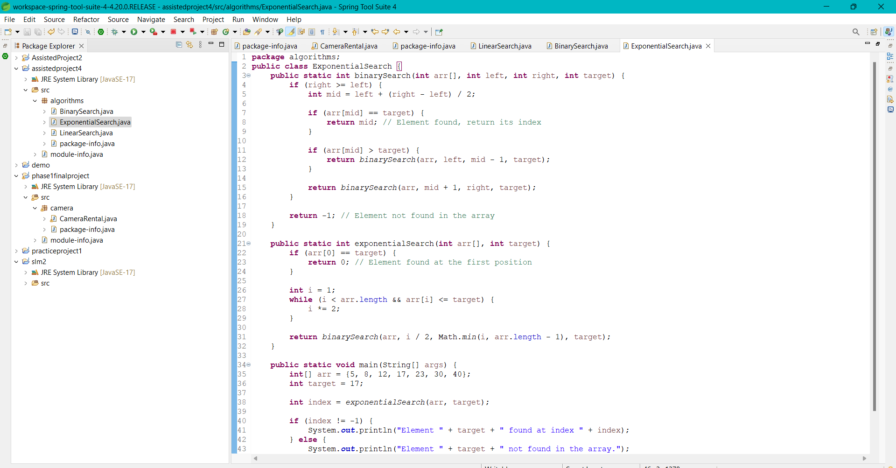

# OUTPUT:

# 